Syphilis Awareness

Hashtags: #CongenitalSyphilis #Syphilis #PregnancyTips #HealthyPregnancy #GetTested #PrenatalVisit

Social Media Posts & Suggested Captions
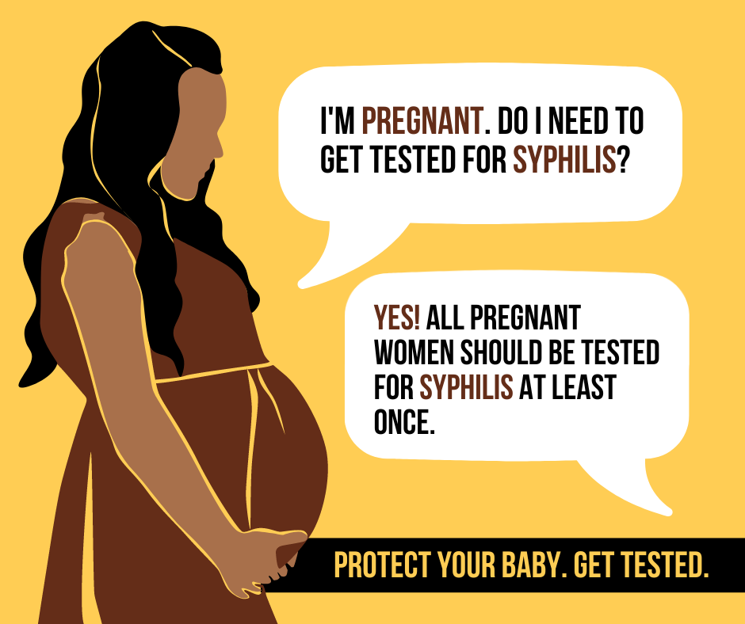  Click here to download | SUGGESTED CAPTION: Did you know? If you’re pregnant you should be tested for syphilis at least once during your pregnancy.  Keep in mind that you can have syphilis and not know it. Many people with syphilis do not have any symptoms. Also, syphilis symptoms may be very mild, or be similar to signs of other health problems. The only way to know for sure if you have syphilis is to get tested. Talk to your healthcare provider about getting screened.
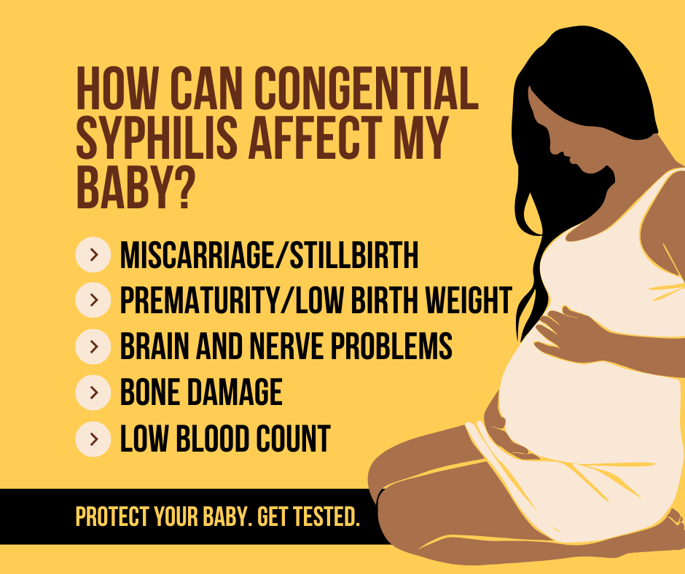  Click here to download | SUGGESTED CAPTION: Congenital syphilis can have major health impacts on your baby. How it affects your baby’s health depends on how long you had syphilis and if — or when — you got treatment for the infection. It is important to make sure you get tested for syphilis at least once during your pregnancy. Talk to your healthcare provider about getting screened.
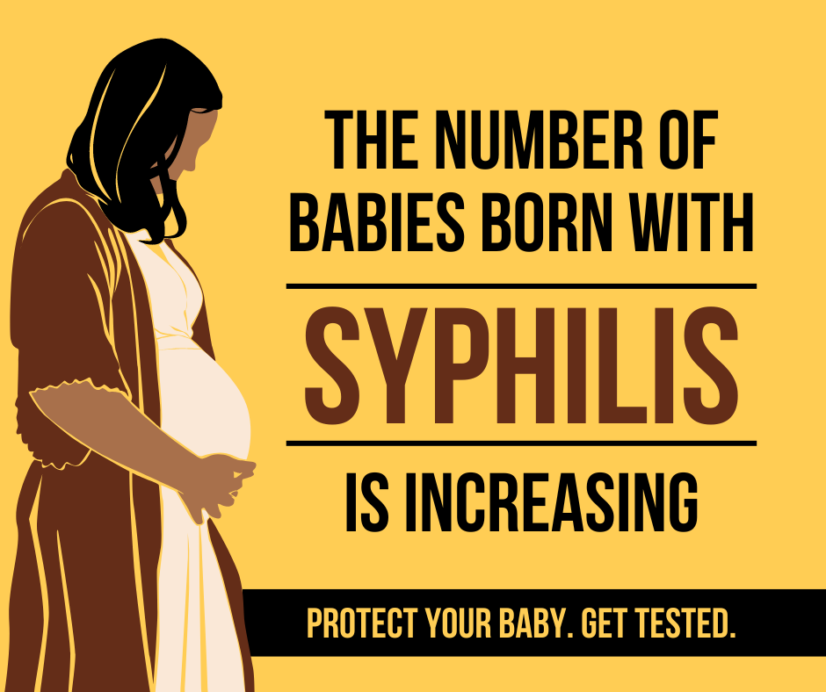  Click here to download | SUGGESTED CAPTION: Protect your baby from congenital syphilis by getting tested for syphilis during your pregnancy. Talk to your healthcare provider during your prenatal visit about getting screened.
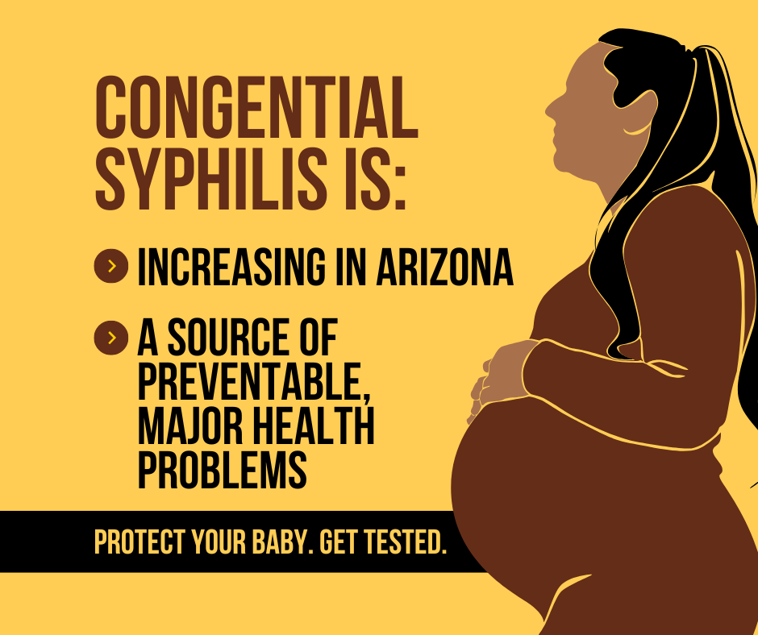  Click here to download | SUGGESTED CAPTION: There has been an increase in the number of babies born with syphilis. Congenital syphilis occurs when a mother with syphilis passes the infection on to her baby during pregnancy and it can have major health impacts on the baby. Talk to your healthcare provider during your prenatal visit about getting screened.
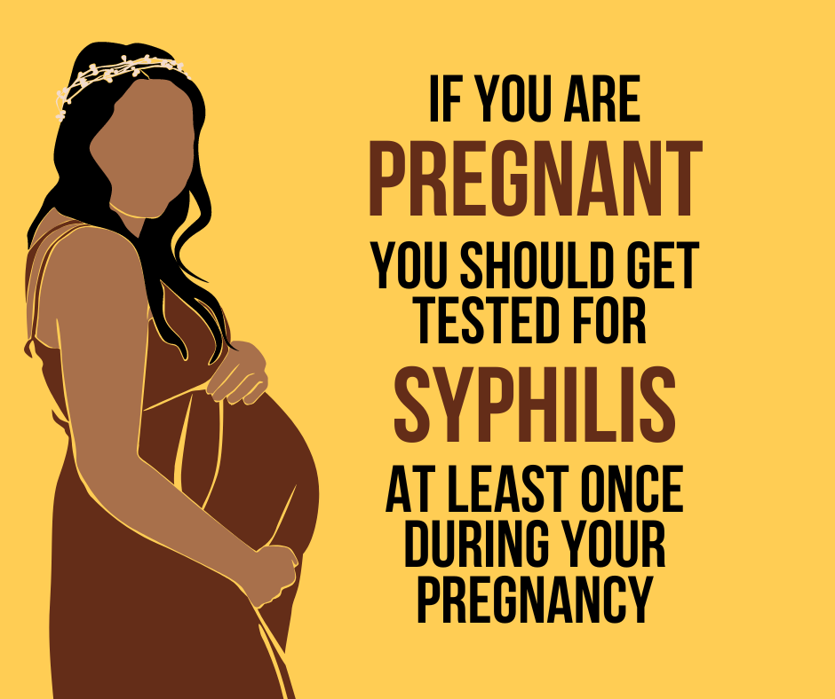  Click here to download | SUGGESTED CAPTION: Getting tested and treated for syphilis can prevent serious health complications in both mother and baby.  Talk to your healthcare provider during your prenatal visit about getting screened for syphilis during your pregnancy. It is important that you have an open and honest talk with your healthcare provider since people with syphilis often have no symptoms. If you test positive for syphilis, you will need to be treated right away.
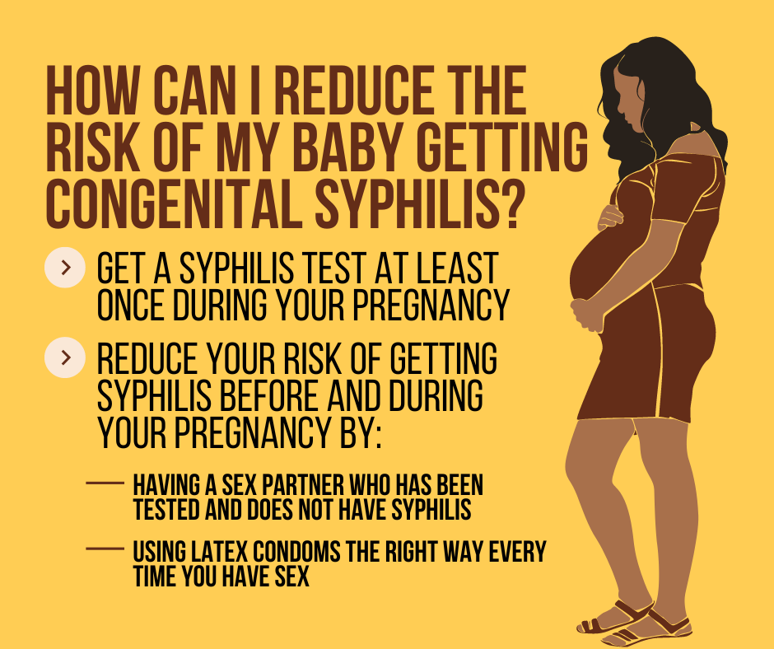  Click here to download | SUGGESTED CAPTION: Your baby will not get congenital syphilis if you do not have syphilis. There are two important things you can do to protect your baby from getting syphilis and the health problems associated with the infection:  1️⃣ Get tested for syphilis at least once during your pregnancy.  2️⃣ Reduce your risk of getting syphilis before and during your pregnancy.  Talk with your healthcare provider about your risk for syphilis. Have an open and honest talk about your sexual history and sexually transmitted infection (STI) testing. Protect your baby and get tested.

DOWNLOAD ALL SYPHILIS AWARENESS GRAPHICS HERE

