Family Care Plans Social Media Toolkit

Post 1:
Are you a parent or pregnant person who uses drugs? Remember that our cultural teachings are very powerful and can teach us how to be well. Learn more here: https://www.indiancountryecho.org/wp-content/uploads/2022/06/2-Culture-Helps-Us-Heal_Final.pdf

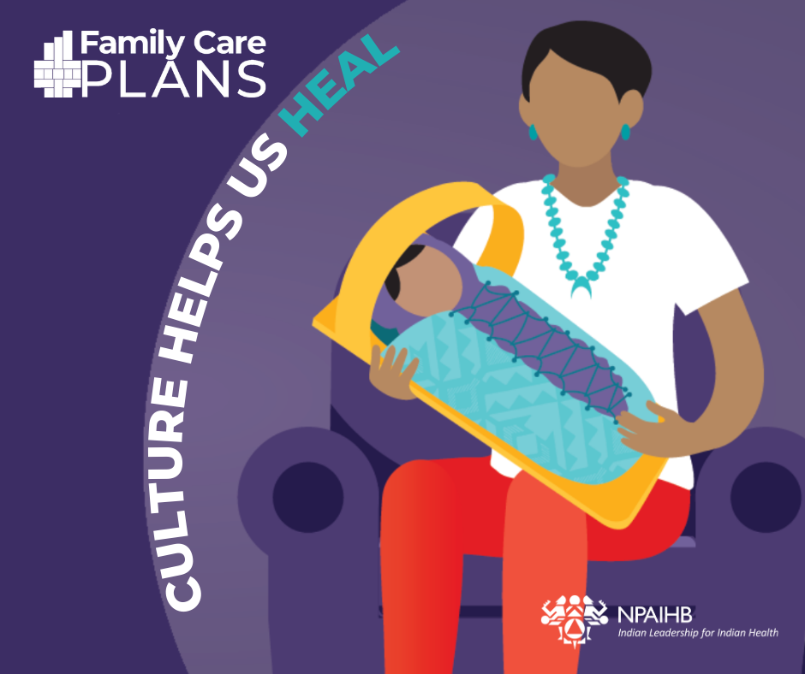
Facebook
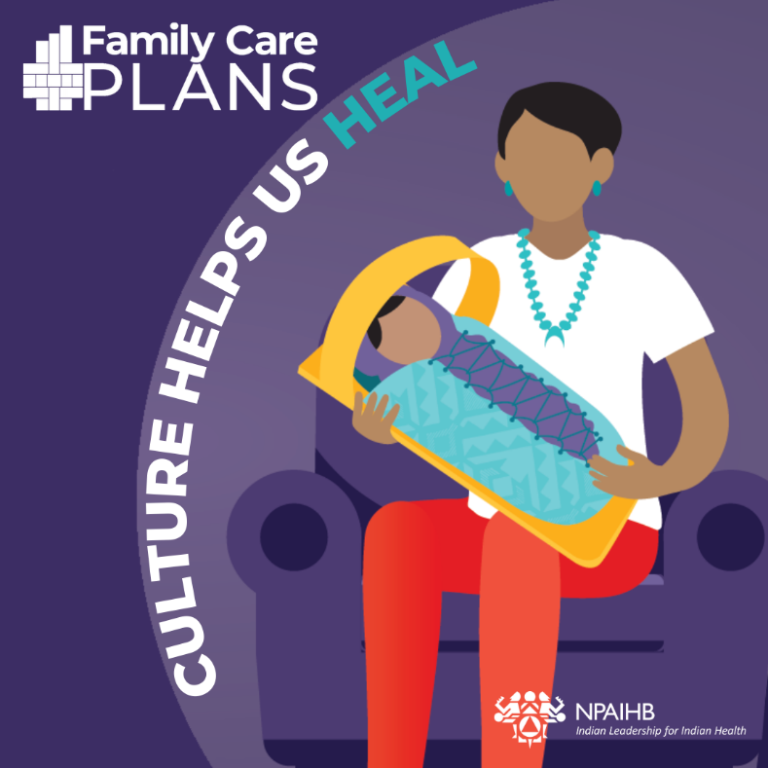
Instagram
Post 2:
Know a parent or pregnant person who uses drugs? Sometimes support can be lifesaving. Learn how you can be a good relative: https://www.indiancountryecho.org/wp-content/uploads/2022/06/6-Supporting-Someone-with-SUD.pdf

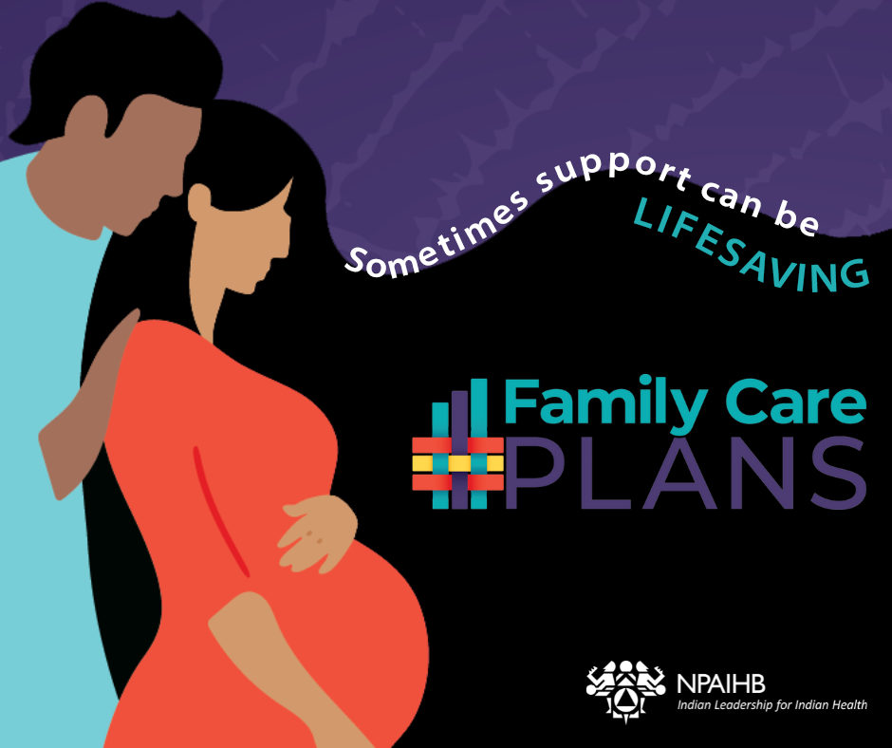
Facebook
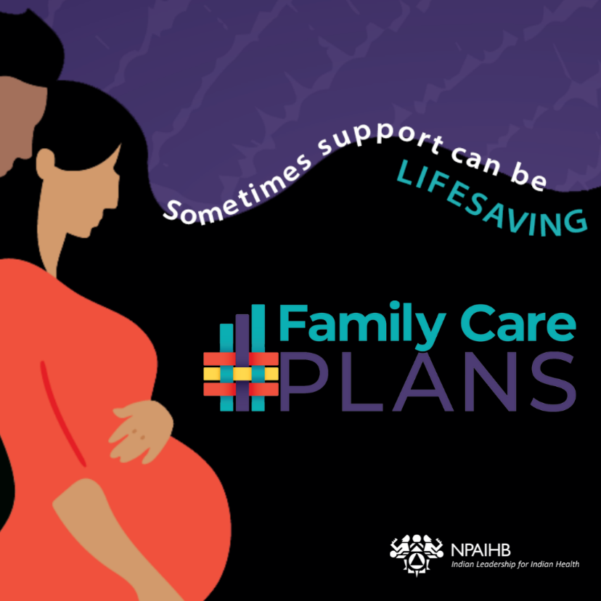
Instagram
Post 3:
To learn the truth about drug use and pregnancy, visit npaihb.org/SUD + check out this handout: https://www.indiancountryecho.org/wp-content/uploads/2022/06/7-The-Truth-About-Substance-Use-and-Pregnancy.pdf

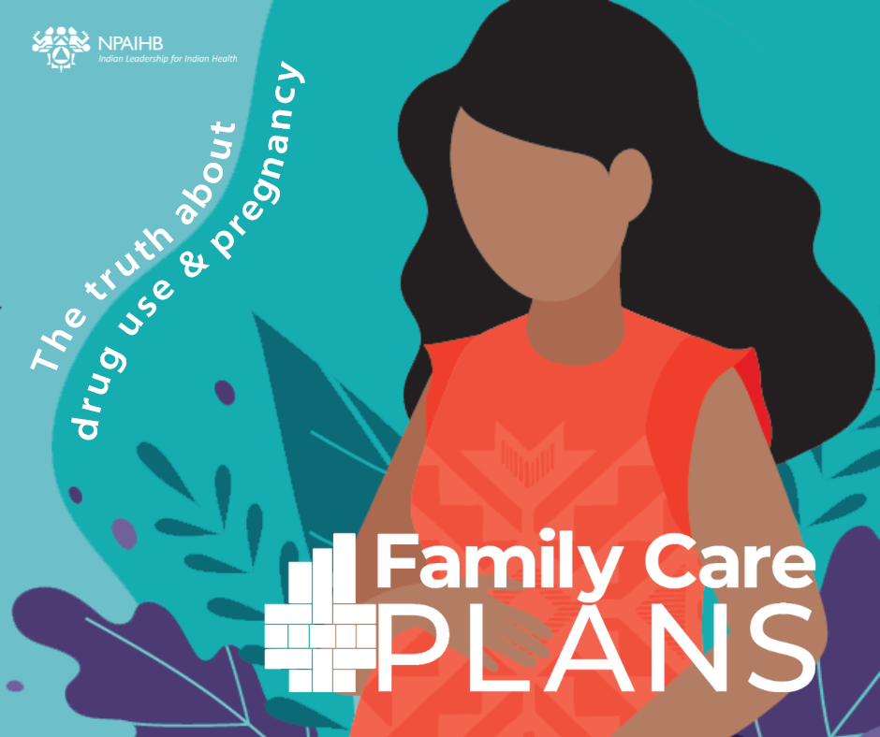
Facebook
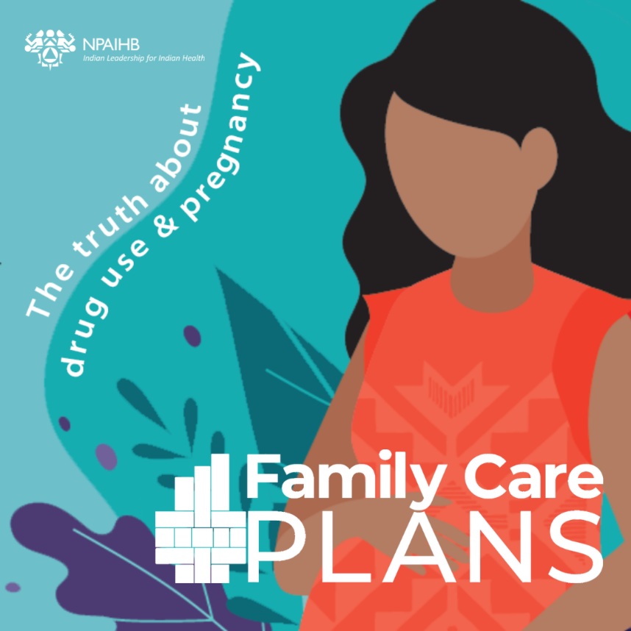
Instagram
Post 4:
Attention Relatives! [insert megaphone emoji] Did you know that pregnant people who use drugs can and do recover? Learn the steps toward recovery: https://www.indiancountryecho.org/wp-content/uploads/2022/06/3-Getting-Help-for-Substance-Use-During-Pregnancy.pdf

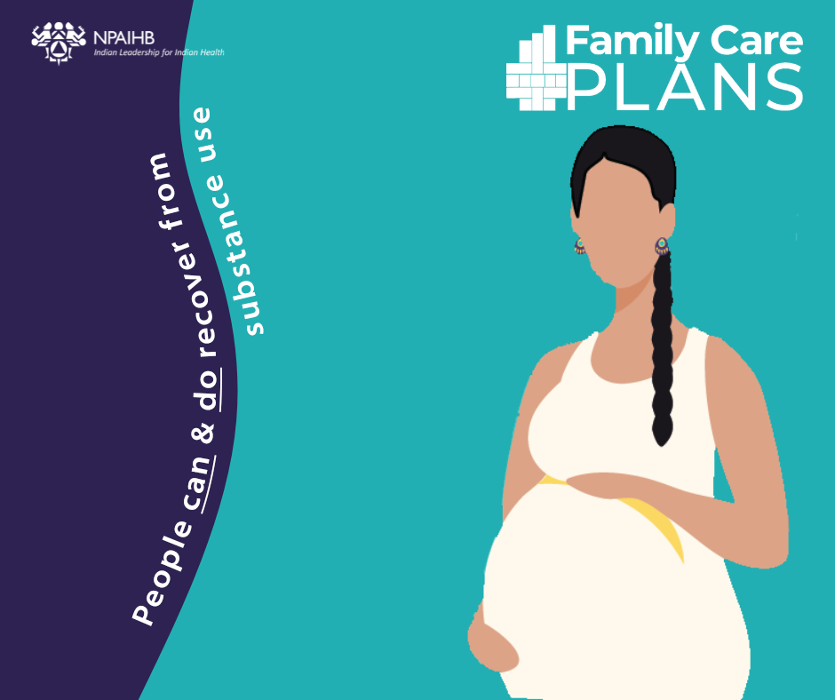
Facebook
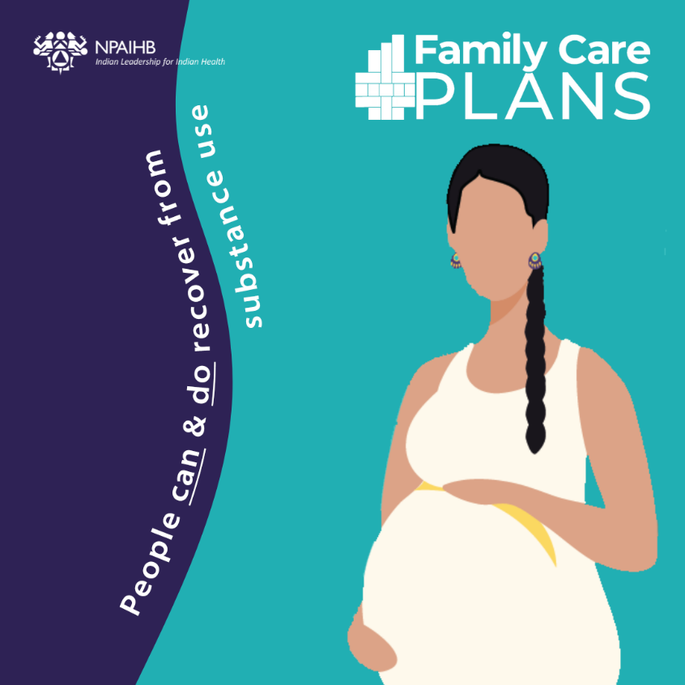
Instagram
Post 5:
Many people who use drugs see their infants and dream of quitting. Fortunately, new parents can and do recover. Learn the steps toward recovery: https://www.indiancountryecho.org/wp-content/uploads/2022/06/4-Getting-Help-for-Substance-Use-New-Parents.pdf

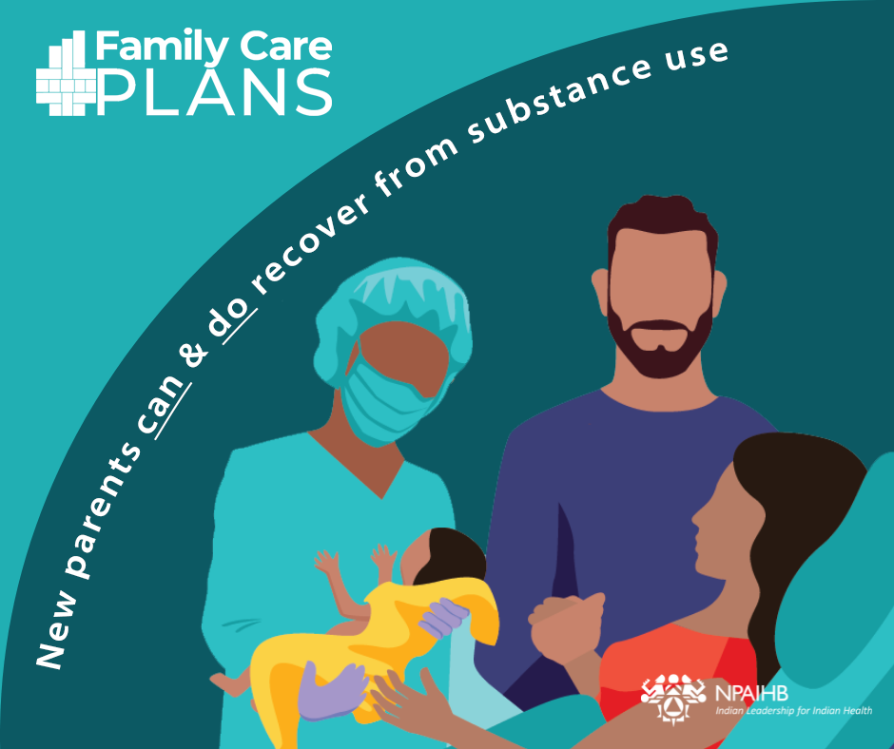
Facebook
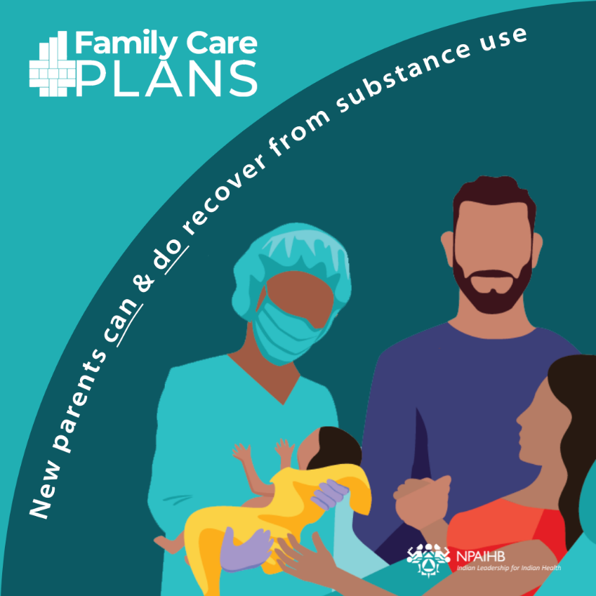
Instagram
Post 6:
Pregnancy and parenthood are sacred times when we make plans to care for ourselves and our baby. When we use alcohol or drugs, it is especially helpful to create a family wellness plan. Start yours here:
https://www.indiancountryecho.org/wp-content/uploads/2022/06/5-NPAIHB_My_Family_Wellness_Plan.pdf
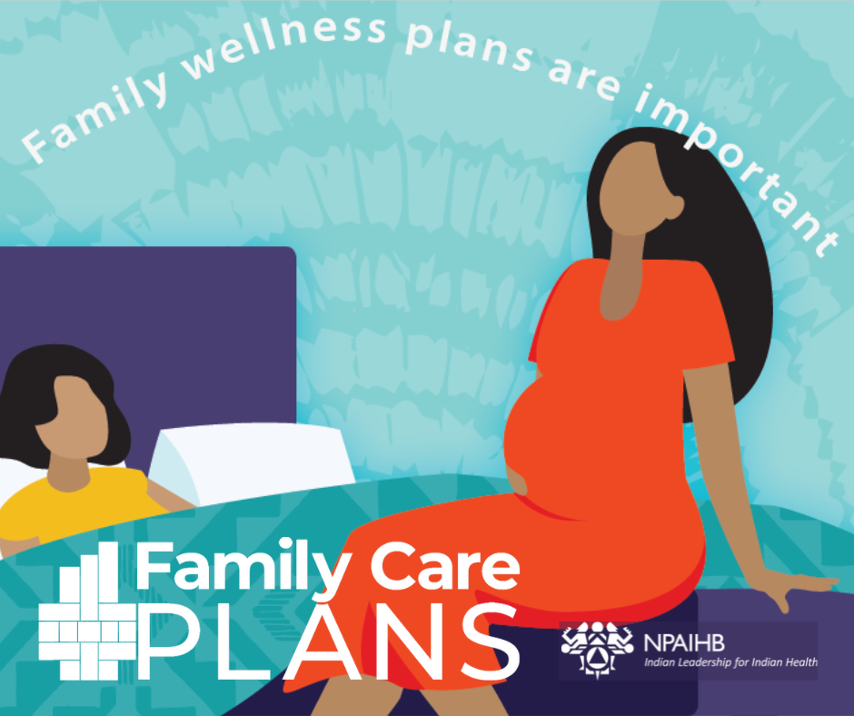
Facebook
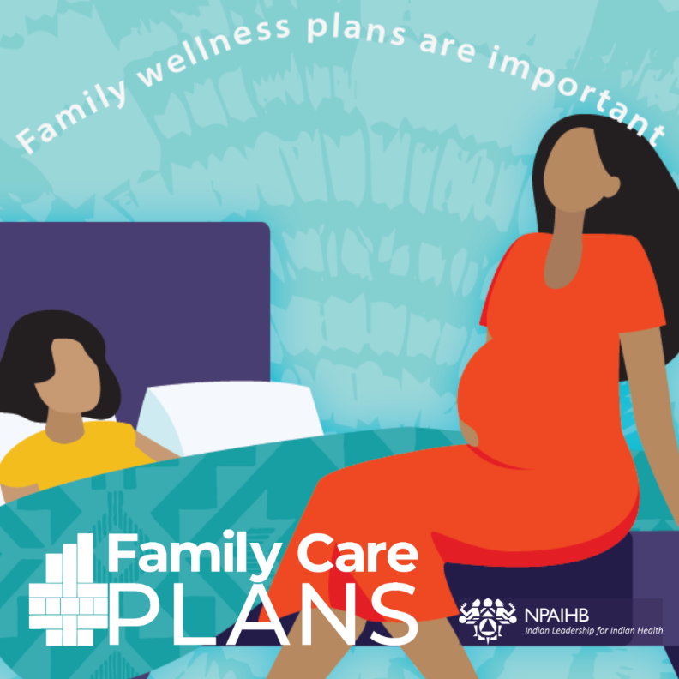
Instagram
Post 7:
Clinicians can have a big impact on improving outcomes for pregnant and parenting people experiencing substance use disorders. Learn more here: https://www.indiancountryecho.org/wp-content/uploads/2022/06/3-Getting-Help-for-Substance-Use-During-Pregnancy.pdf

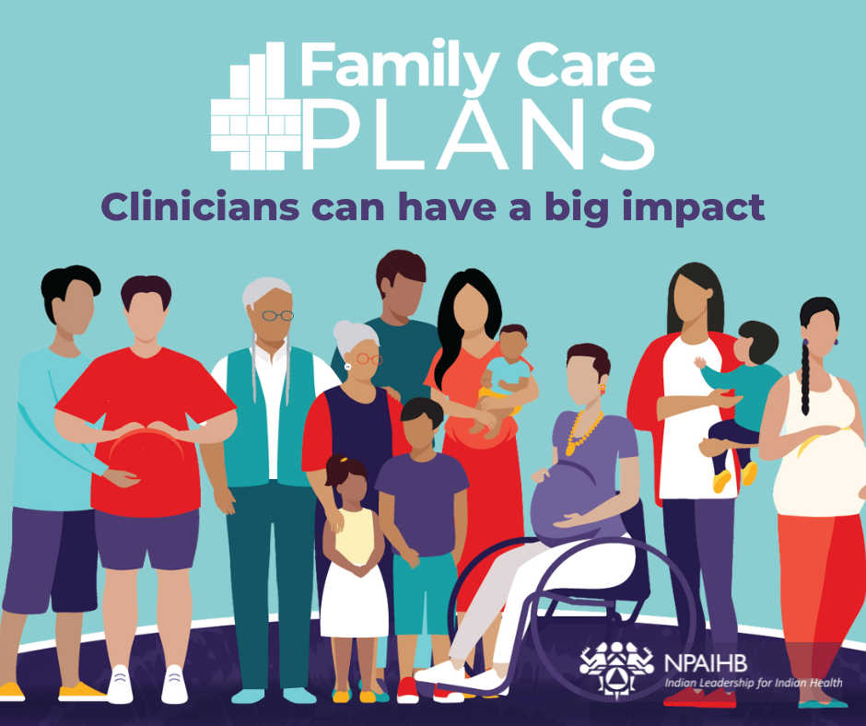
Facebook
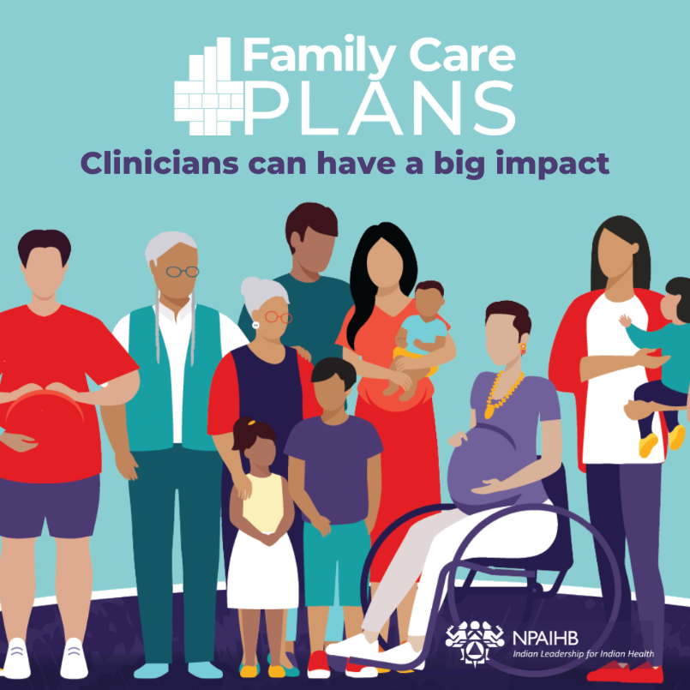
Instagram

