VacciNative Humor is Medicine Social Media Toolkit
Feel free to add your organization’s logo alongside the VacciNative logo on each social media post.

Post 1: It doesn’t have to be THAT complicated! Keep grandma safe by getting vaccinated… so we can learn all of her secrets. ❤️❤️❤️ Learn more: www.IndianCountryECHO.org/VacciNative

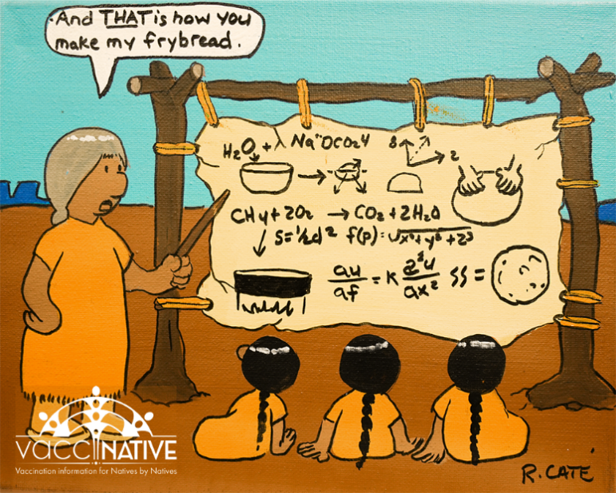

Facebook

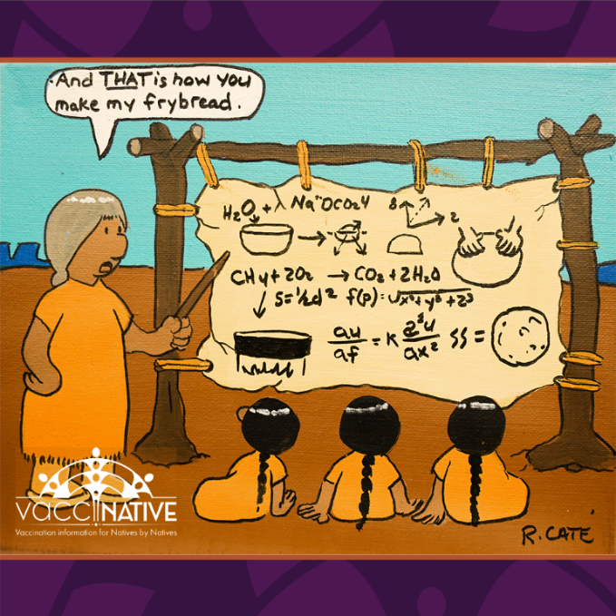
Instagram
Post 2: Is it a bird?! No… Is it a plane?! No…. It’s the superhero every rez needs! [insert three fire emojis] Protect your community by getting vaccinated. Learn more: www.IndianCountryECHO.org/VacciNative

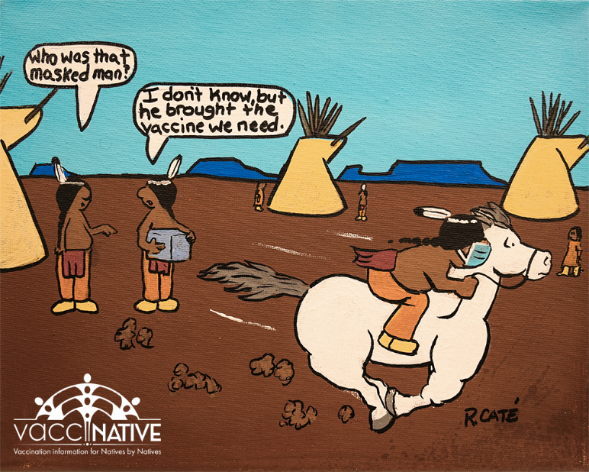
Facebook

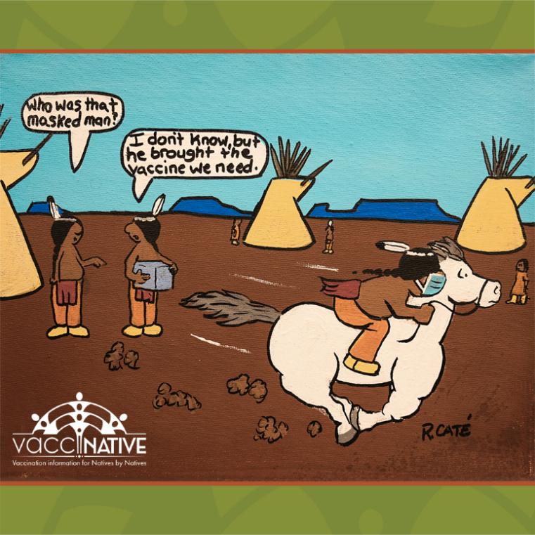
Instagram

Post 3: “Hey Victoooorrrr, let’m know the vaccines are here!!!” We’ve been sending smoke signals since the beginning of time. [insert laughing emoji] To stay protected, connected, and informed, visit: IndianCountryECHO.org/VacciNative

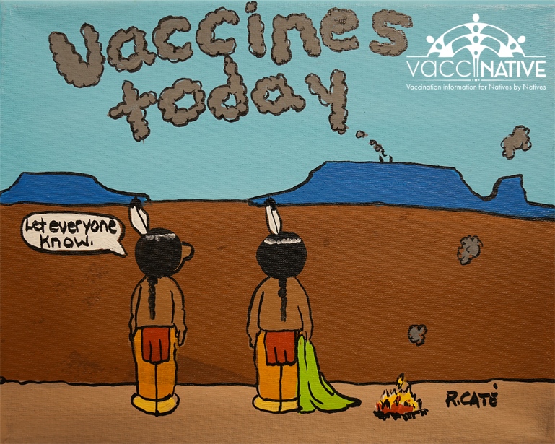
Facebook

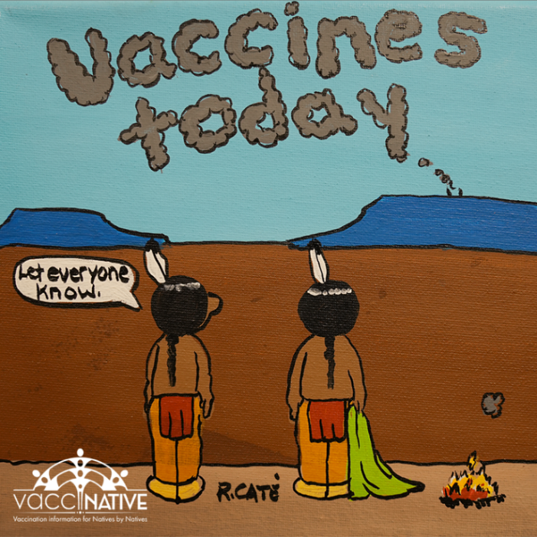
Instagram

Post 4: When it comes to getting vaccinated, we need EVERYONE to do some heavy lifting. When healthy people get vaccinated, it helps keep vulnerable people safe. Get your vax facts by Natives for Natives at: www.IndianCountryECHO.org/VacciNative

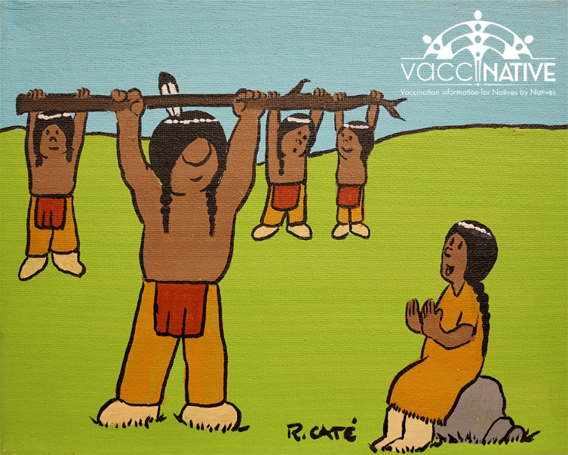
Facebook

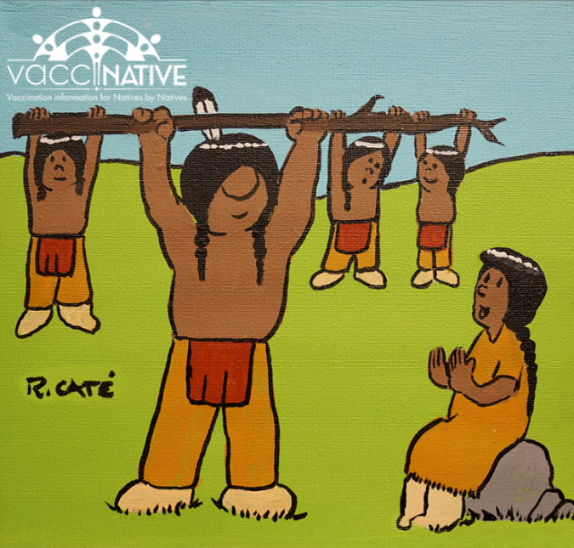
Instagram

Post 5: Be brave. Everyone can do their part to protect their community! For accurate vaccination info for Native people by Native people, visit: www.IndianCountryECHO.org/VacciNative

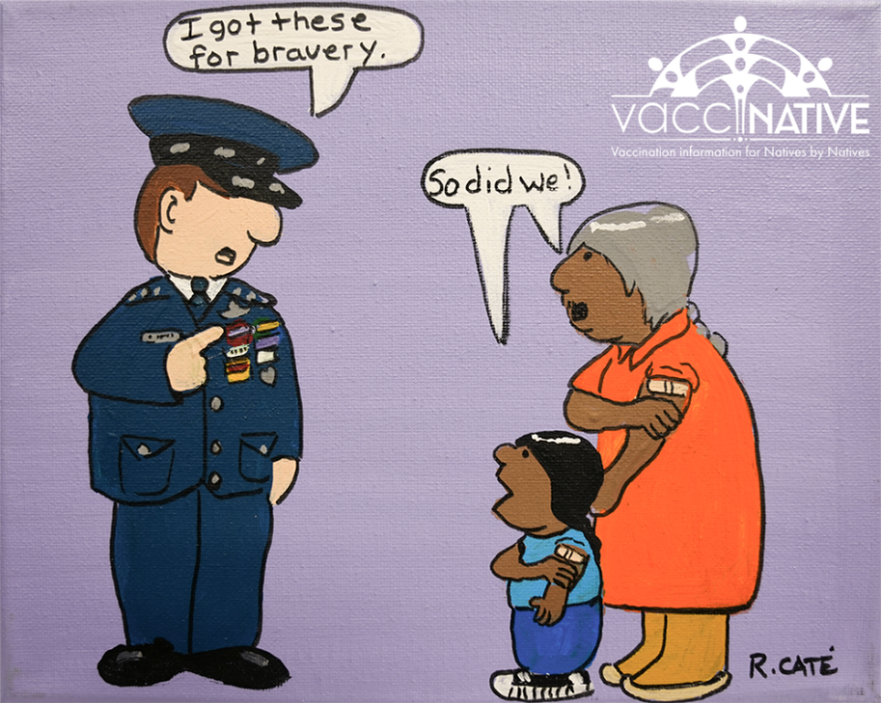
Facebook

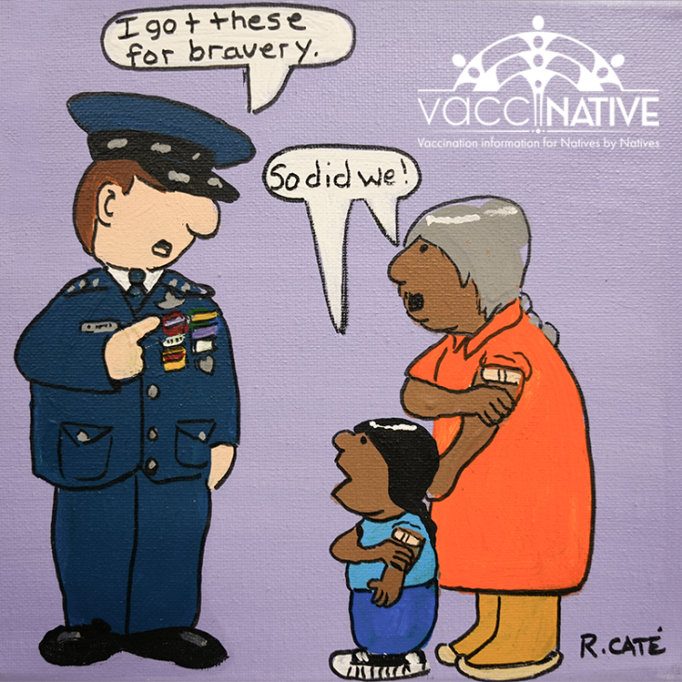
Instagram
Post 6: Everyone can be a community leader! Stop serious illnesses from spreading by staying up to date on your vaccines. For vaccination info for Native people by Native people, visit: www.IndianCountryECHO.org/VacciNative
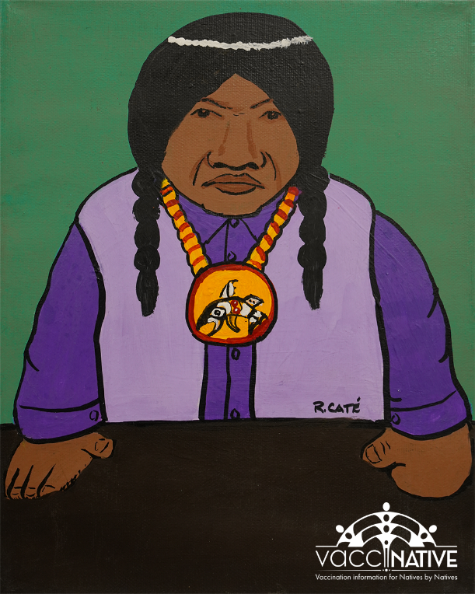
Facebook

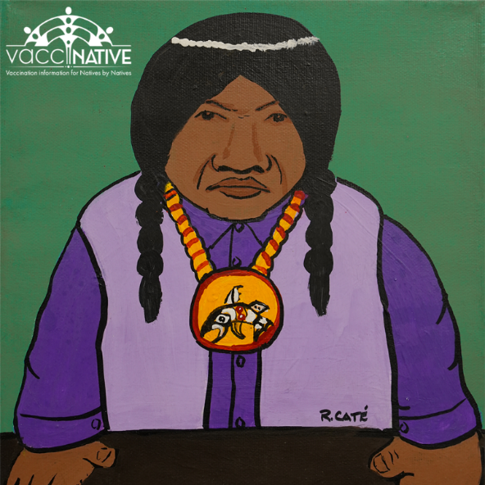
Instagram

Post 7: Did you know that vaccine side effects - like mild aches and fever - are actually a good sign!? It means that your body is preparing to protect you! To get accurate vaccine info for Native people by Native people, visit: IndianCountryECHO.org/VacciNative

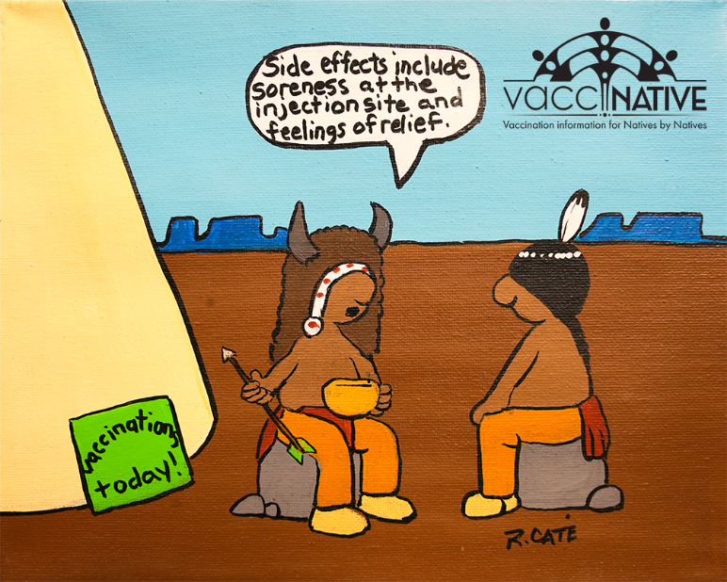
Facebook

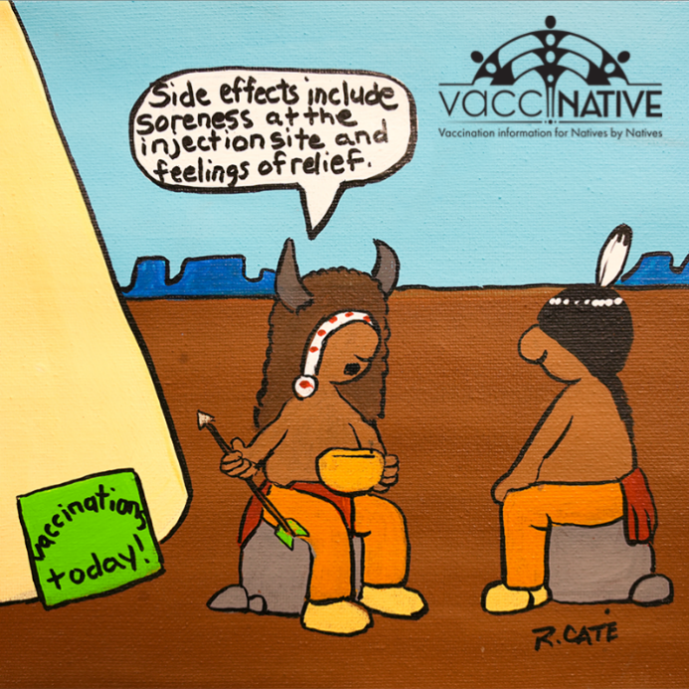
Instagram
Post 8: Here’s the buzz…. [insert three bee emojis] Getting vaccinated protects you and your community from many serious illnesses. However, some of us have fears about vaccines. Check out this handout to help calm your nerves and overcome your fears: https://www.indiancountryecho.org/wp-content/uploads/2023/03/VacciNative_Overcoming_Vaccination_Fears_508.pdf

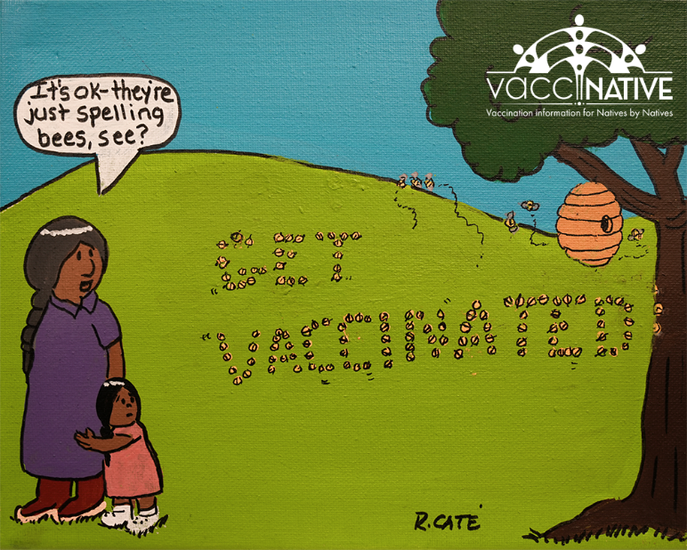
Facebook

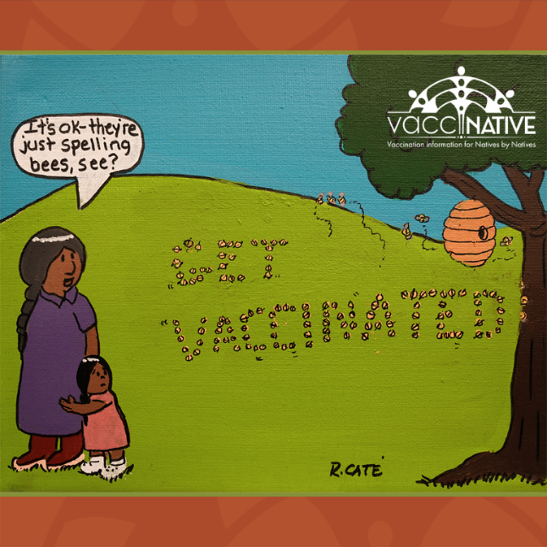
Instagram

Post 9: Even man’s best friend knows how pawsome vaccines are! 🐾 So, make sure you, your family, and your pups are up to date on your vaccines. Learn more at: IndianCountryECHO.org/VacciNative

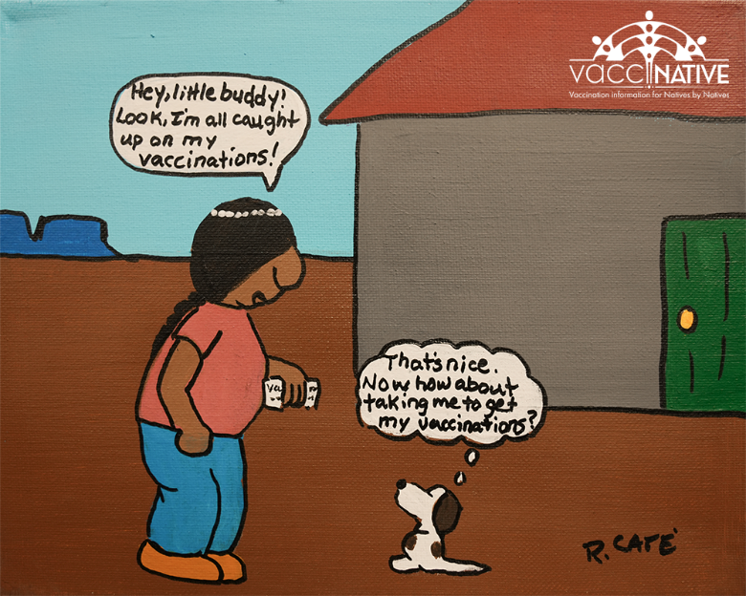
Facebook

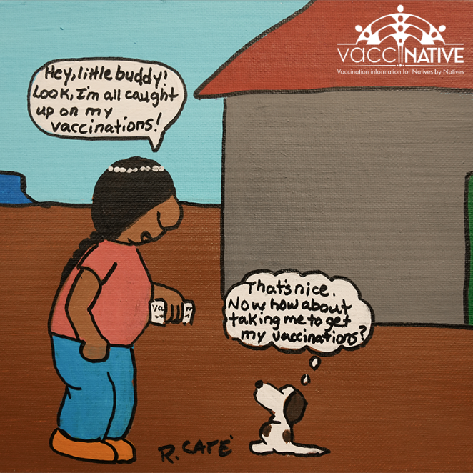
Instagram

Post 10: It’s not too late! We are giving ____ [insert type of vaccine] shots today. So stop by ________ [insert location] between [insert times].
Get accurate vaccine information for Native people by Native people at: IndianCountryECHO.org/VacciNative

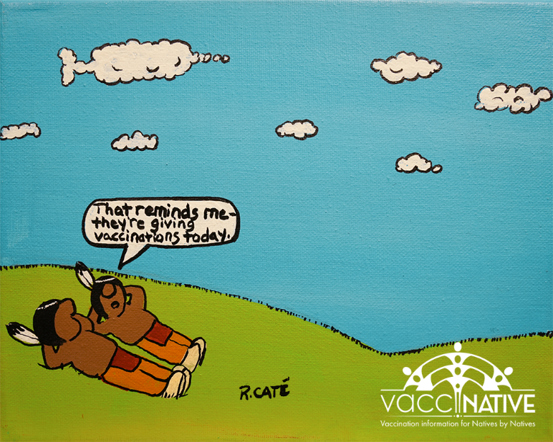
Facebook

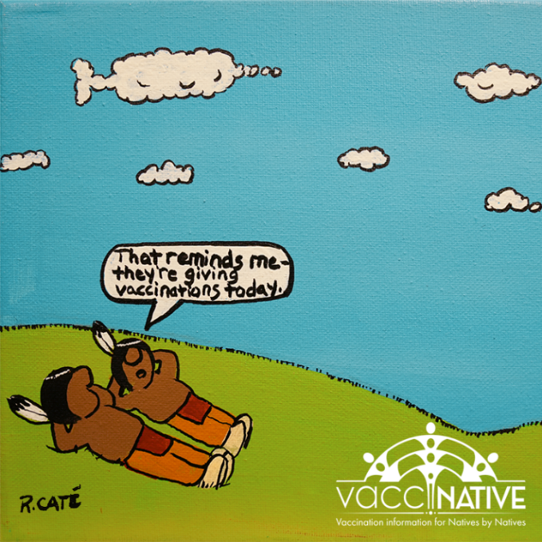
Instagram
Post 11: Some things are just written in the sta-… the birds! Remember to stop by ____________ [insert location] to get vaccinated. We are giving ____ [insert type of vaccine] shots today. So stop by ________ [insert location] between _________ [insert times].
Get accurate vaccine information for Native people by Native people at: IndianCountryECHO.org/VacciNative

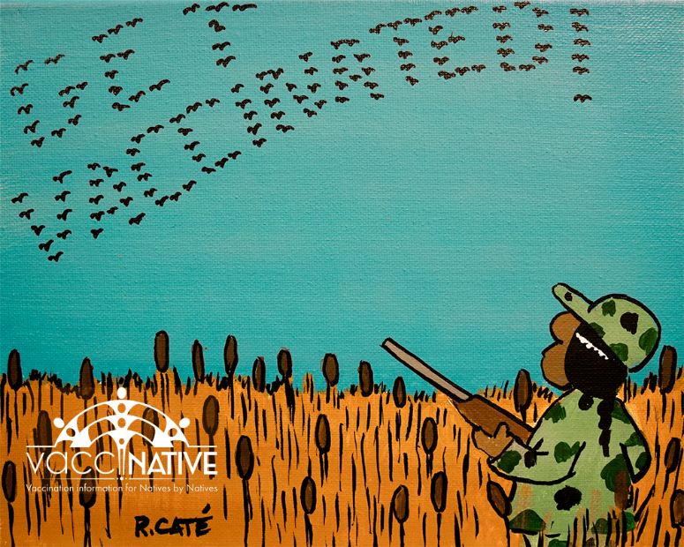
Facebook

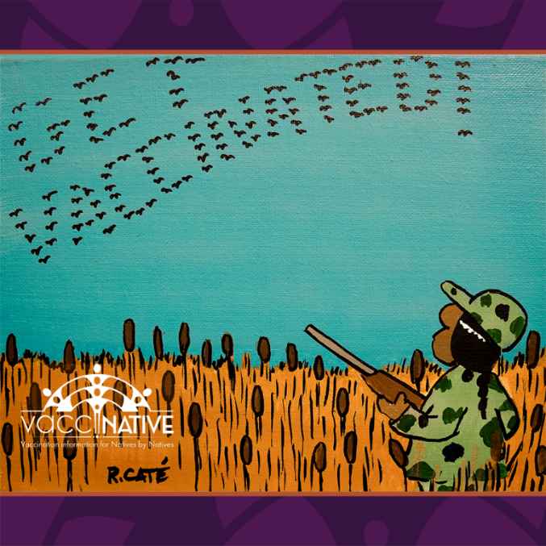
Instagram
Post 12: Where the aunties at?! [insert laughing emoji] For accurate vaccine info for Native people by Native people, visit: IndianCountryECHO.org/VacciNative
[Want to change the text on the sign? Contact us. We can adapt it for you community! ]

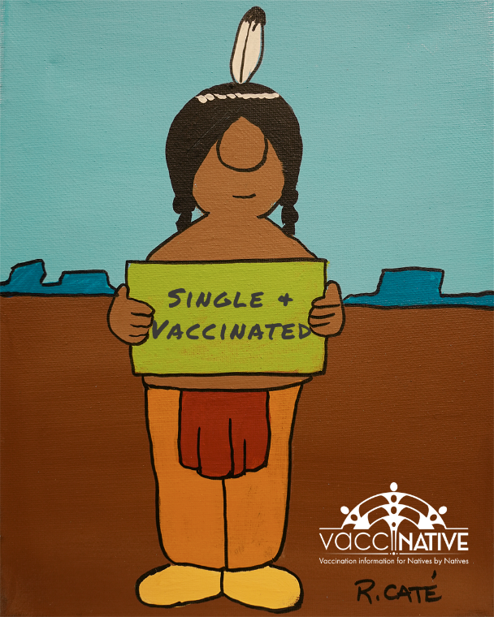
Facebook

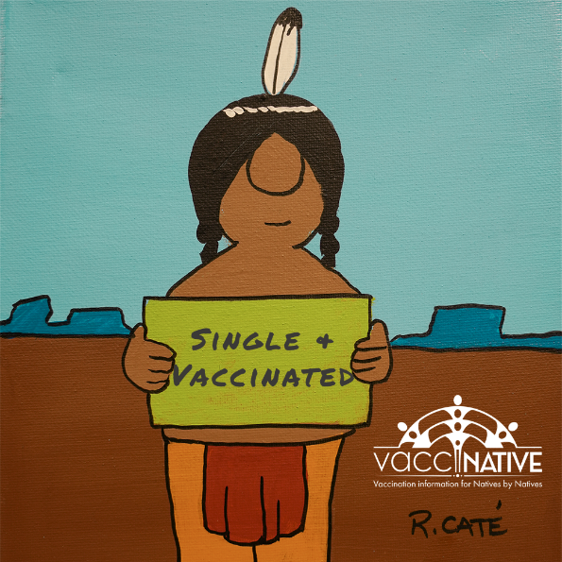
Instagram

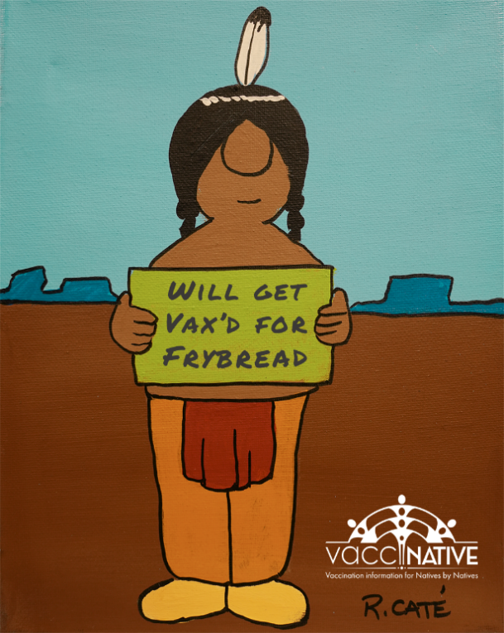
Facebook

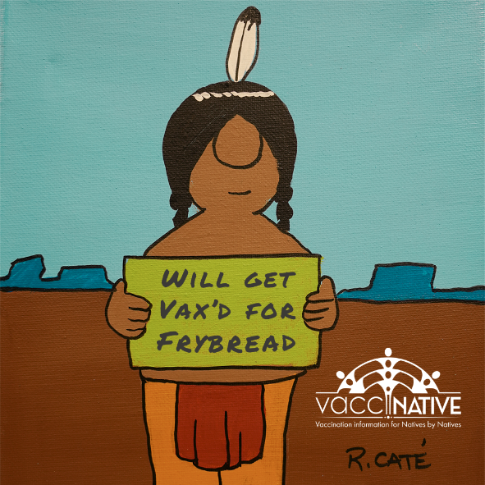
Instagram

