MGB Bridge clinic

**For Treatment of Substance Use Disorders**

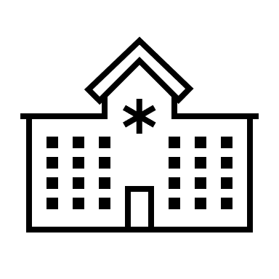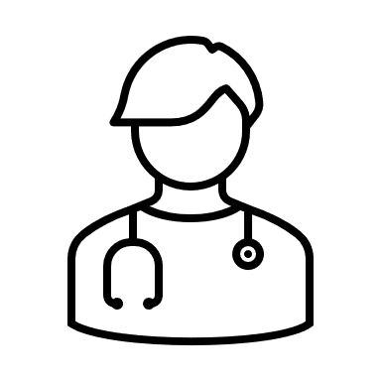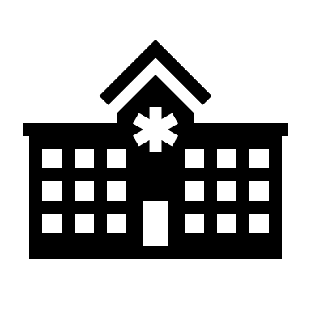Bridge clinics offer immediate access to alcohol, substance use disorder, and addiction treatment. We understand that change is difficult and want to support you in your recovery journey by welcoming you with compassionate, non-judgmental, individualized care. We value individual differences and aim to create an environment that welcomes all races, ethnicities, languages, and walks of life.

**Salem Hospital Bridge Clinic**

55 Highland Avenue, Suite 201

Salem, MA 01970

*Pho*ne: (978) 354-2050

**Merrimack Valley Bridge Clinic**

600 Primrose St. Suite 100   
Haverhill, MA 01830  
*Phone:* (978) 469-5536

**MGH Bridge Clinic**

55 Fruit Street, Cox 1, Suite 110

Boston, MA 02114

*Phone*: (617) 643-8281

**BWH Bridge Clinic**

75 Francis Street, Suite 159

Boston, MA 02115

*Phone*: (617) 278-0172

**You are connected to a Bridge clinic**

**You work with an addiction provider, therapist, and recovery coach**

**Once ready, you will transition to a long-term provider**

Bridge Clinic Mission

* **Immediate Access:**  Walk-in and scheduled visits within 24-48 hours of a referral are available and can include access to medication when appropriate.
* **Low Threshold:** There are no requirements to access treatment. We offer virtual, telephone, and in-person visits and aim to have a flexible schedule that suits your needs.
* **Person-Centered:** The goals are defined by you and driven by you. How you decide to begin or continue your recovery journey will be a collaborative process with your provider.
* **Transitional Care:** This is one of many doors that will be available for treatment. Our goal is to get you treated, stabilized, then support you in transitioning to a long-term treatment. The Bridge Clinic has an open-door policy, meaning you can always return if needed.

Bridge Clinic Services

* **Medication** for treatment of substance use disorders   
  **Treatment** of all substance use disorders (alcohol, stimulants, opioids, cocaine, benzodiazepines, cannabis etc.)
* **Peer Support** throughout your recovery
* **Referrals to community resources** such as housing, transportation, food, employment, identification cards, mobile phones
* **Co-treatment of other medical and psychiatric conditions** such as depression/anxiety, infection related to substance use
* **Harm reduction** services and resources
* **Overdose** education and access to naloxone
* **Bridge** to long-term providers

Bridge Clinic Care Team

* **Medical providers and therapists with expertise in addiction treatment**
* **Recovery Coaches with lived experience**



