Feel free to add your organization’s logo alongside the VacciNative logo on each social media post.

Post 1:
To take care of our bodies we can work on getting enough sleep, reducing stress, eating well, and staying connected. We also have traditional medicines, naturopathic medicines (like vitamins and supplements), and allopathic medicines (like vaccines). By using what’s available to us, we can stay vibrant. This allows us to pass on our traditional values, languages, and cultures.

Learn more: www.IndianCountryECHO.org/VacciNative and https://youtu.be/T2kxyGUu_jM

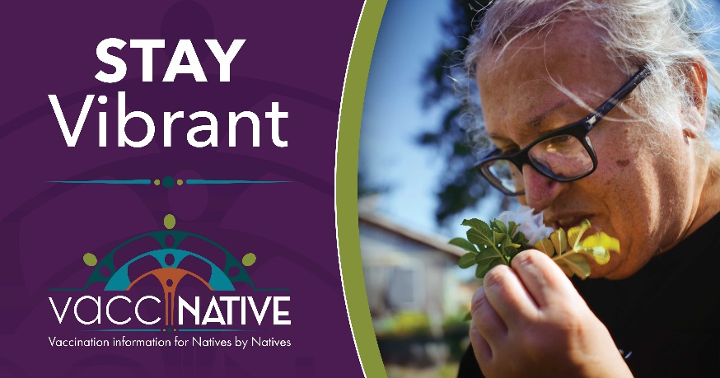
Facebook
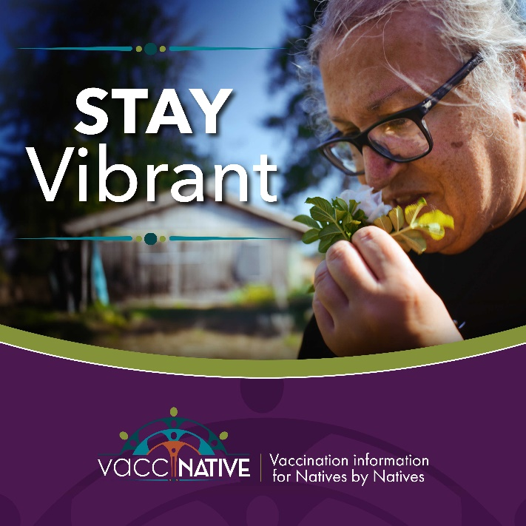
Instagram
Post 2:
“My mother’s older sister and baby died during the flu epidemic. I don’t ever hesitate to take a shot. I believe in shots. I want everyone to get vaccinated because I want you to continue to be alive. I don’t want you to be ill.”
- Auntie Marie, Lummi Nation Elder

Watch Auntie Marie’s story: https://youtu.be/LkeaOw4Jzwo

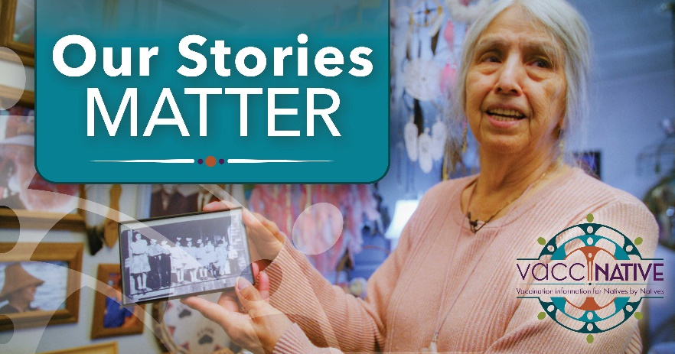
Facebook
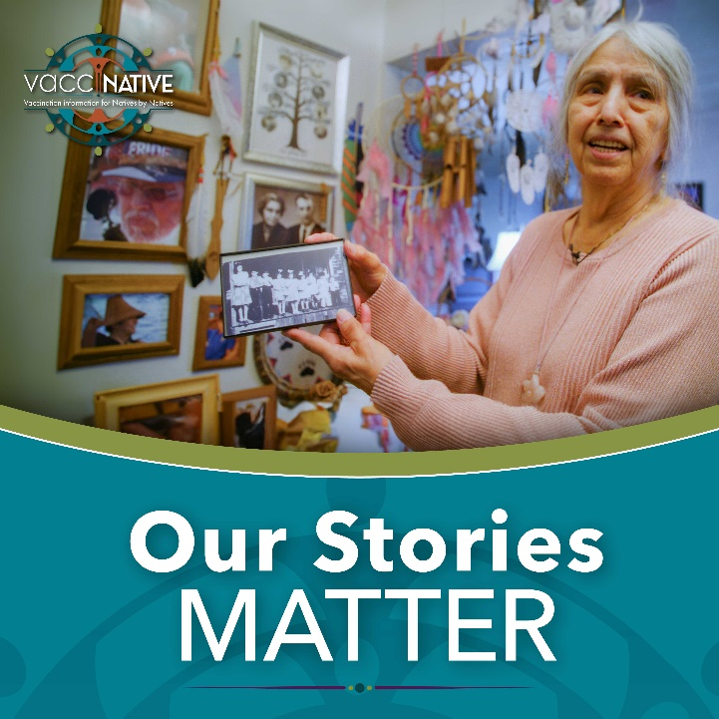
Instagram

Post 3:
Our ancestors’ teachings are the reason we are still here. Getting vaccinated against illnesses ensures we can carry on their legacy of resistance and resiliency.

Stay protected, connected, and informed. Learn more: www.IndianCountryECHO.org/VacciNative and https://youtu.be/LkeaOw4Jzwo

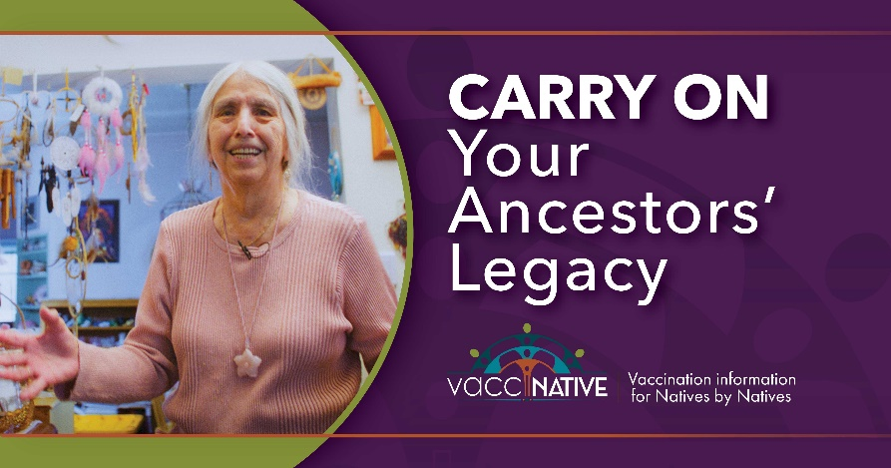
Facebook
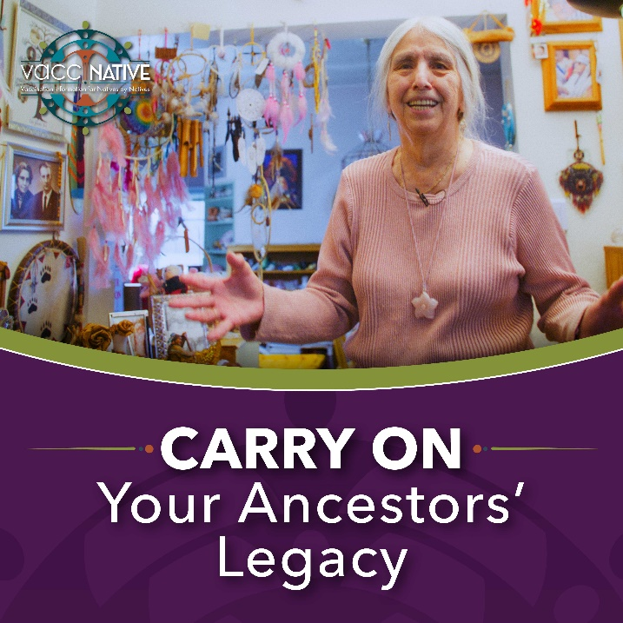
Instagram

Post 4:
“Getting vaccinated doesn’t have to interfere with your holistic approach to life. We have to bring in modern medicine. It will help you live longer, which I think most of us want to do.” – Gretchen LaDue, Cowlitz Tribal Elder
Learn more: www.IndianCountryECHO.org/VacciNative and https://youtu.be/T2kxyGUu_jM

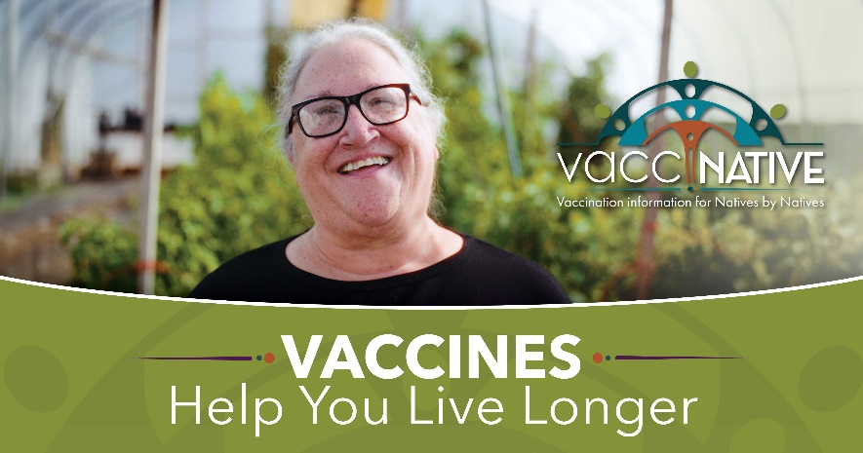
Facebook
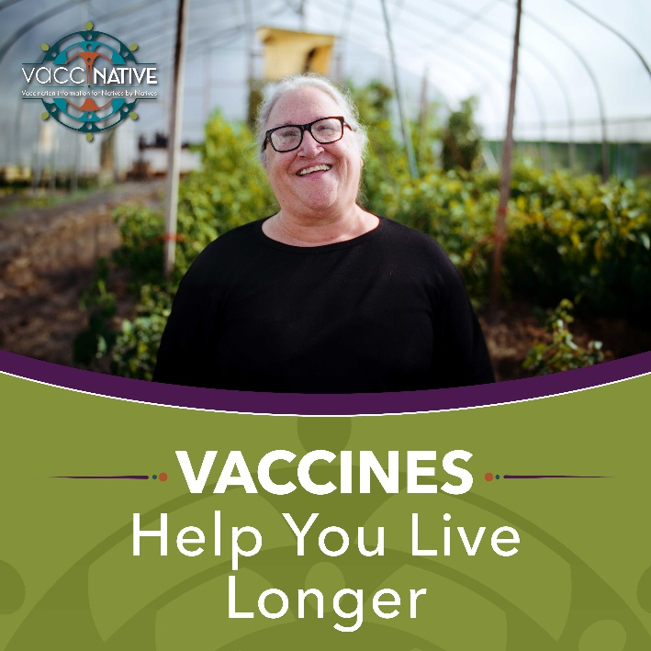
Instagram

Post 5:
“Vaccines are a part of a holistic approach to health. I make sure to get vaccinated for my friends, my family, my Tribe, and my community.” – Gretchen LaDue, Cowlitz Tribal Elder

Stay protected, connected, and informed. Learn more: www.IndianCountryECHO.org/VacciNative and https://youtu.be/T2kxyGUu_jM

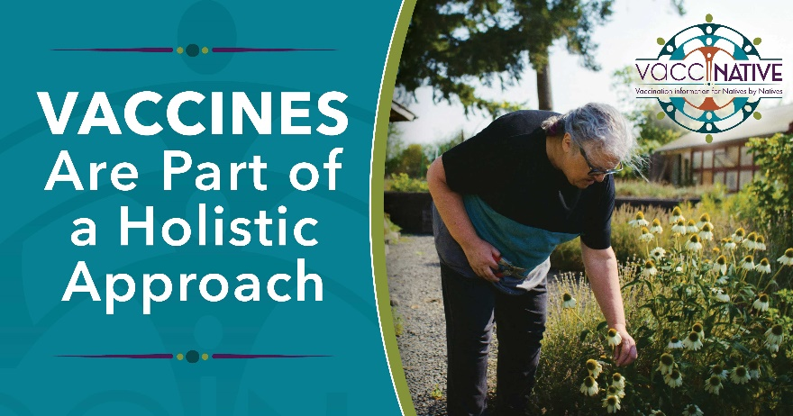
Facebook
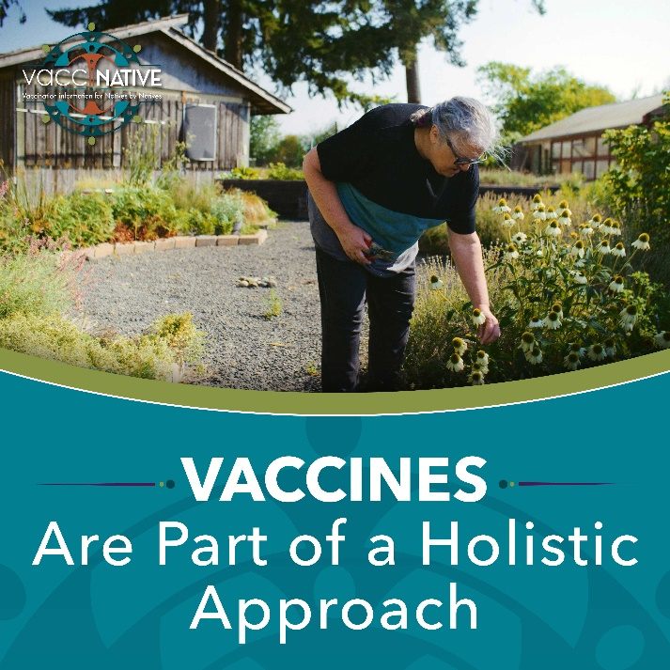
Instagram

Post 6:
As Elders, it’s important that we get vaccinated along with our family members. By getting vaccinated, we can protect our cultures and help our traditions grow.
Stay protected, connected, and informed. Learn more: www.IndianCountryECHO.org/VacciNative and www.youtube.com/watch?v=D2q6WyEBuzs

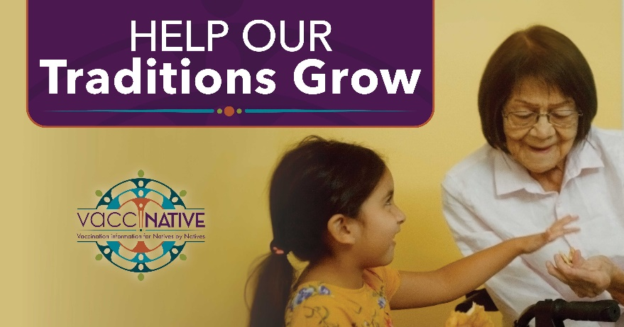
Facebook
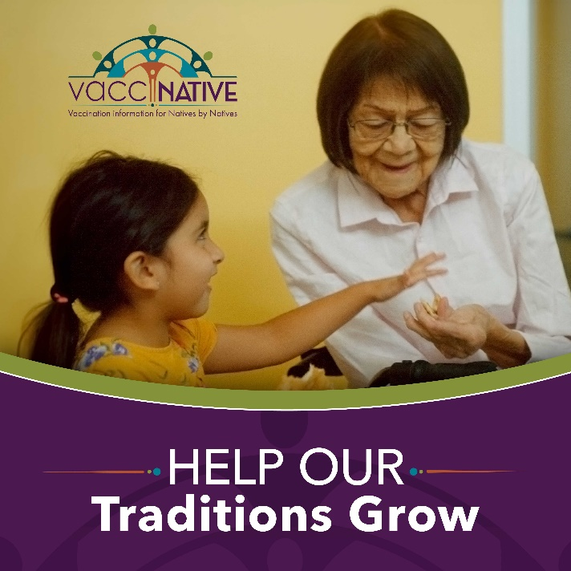
Instagram

Post 7:
Caring for our health is a sacred act. As Elders, part of caring for ourselves and our families involves making sure we are up to date on our vaccines.

Stay protected, connected, and informed. Learn about six vital vaccines for Elders: [Link to “6 Vital Vaccines for Elders” handout]

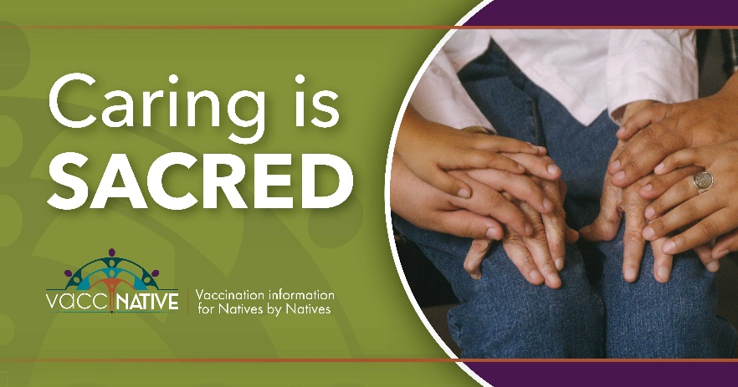
Facebook
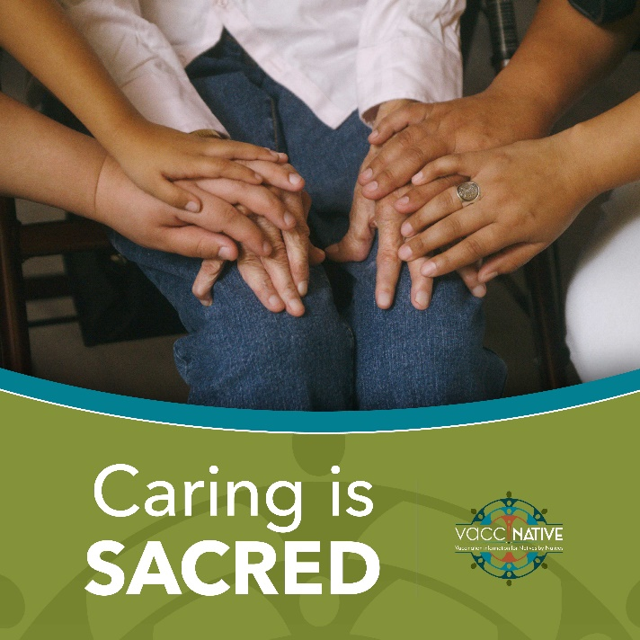
Instagram

Post 8:
“In the past we have been affected by diseases and lost family members and community members. Today, we’re fortunate. Vaccines prevent diseases from harming our communities to the extent they did before.”
– Dr. Lakota Scott, Diné, Naturopathic doctor

To learn more, visit: www.IndianCountryECHO.org/VacciNative and https://youtu.be/KZdYrKnfEac

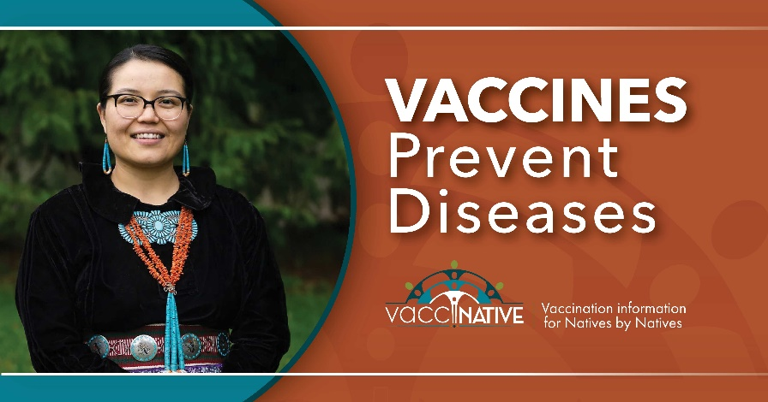
Facebook
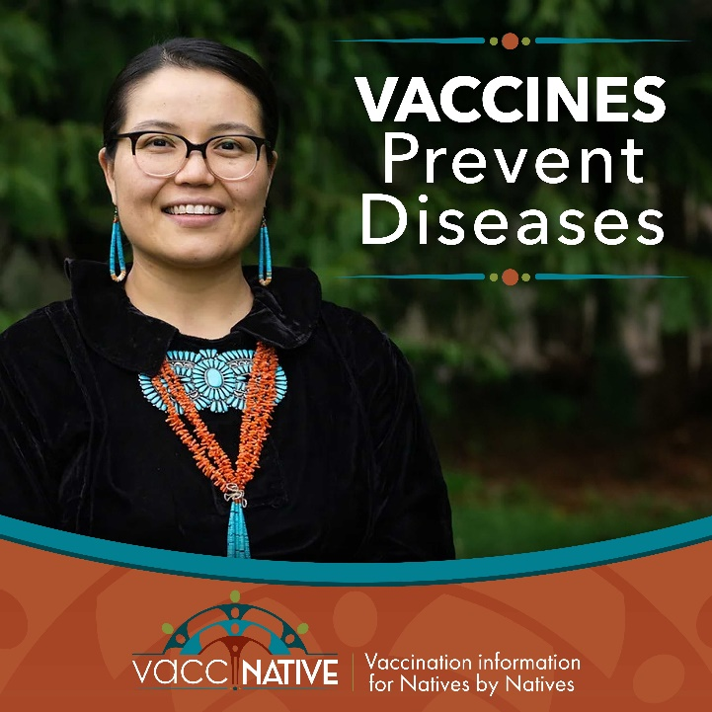
Instagram

Post 9:
“See that picture on the wall. Mom said that was her sister. She died during the flu epidemic.” - Aunt Marie, Lummi Nation Elder

Our ancestors faced many serious respiratory illnesses. Some even died from them. Respiratory illnesses - like flu, RSV, and COVID - are still very serious today. However, nowadays we are fortunate to have vaccines that can help us protect ourselves and our communities. Learn more: [Link to “Respiratory Illnesses” handout]

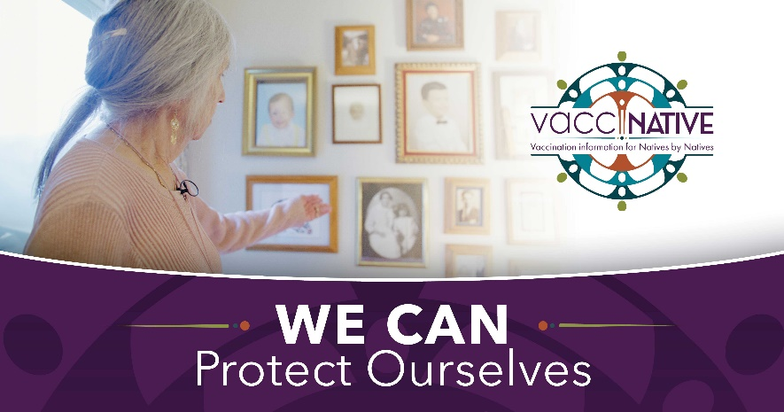
Facebook
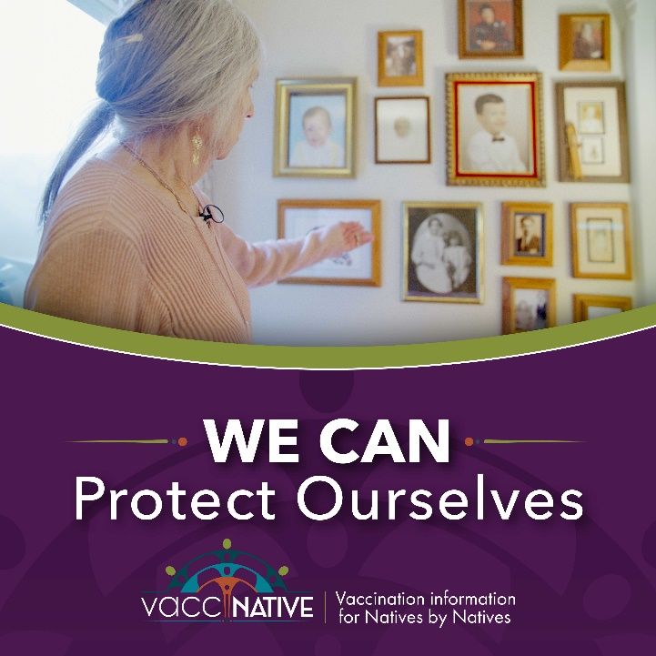
Instagram

Post 10:
Did you know vaccines are especially important for Elders? As we get older, it’s harder to fight off infections. However, vaccines help us stay protected while we stay connected.
Learn more: [Link to “6 Vital Vaccines for Elders” handout] and www.youtube.com/watch?v=D2q6WyEBuzs

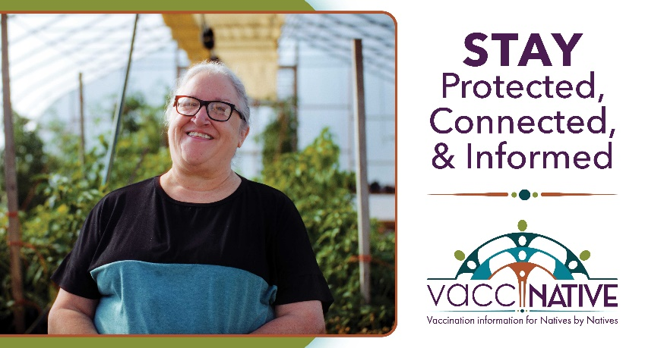
Facebook
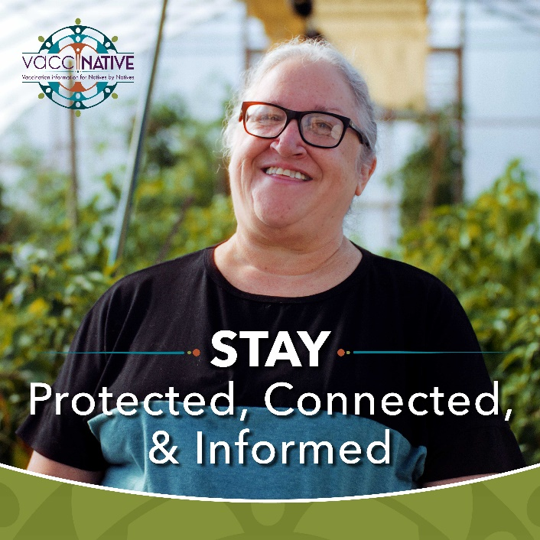
Instagram

Post 11:
As Elders, spending time with family is everything. But, especially after COVID, we may worry about attending large gatherings. To stay protected from illness while we stay connected, it’s important to be up to date on our vaccines. Learn more: [Link to “6 Vital Vaccines for Elders” handout] and www.youtube.com/watch?v=D2q6WyEBuzs

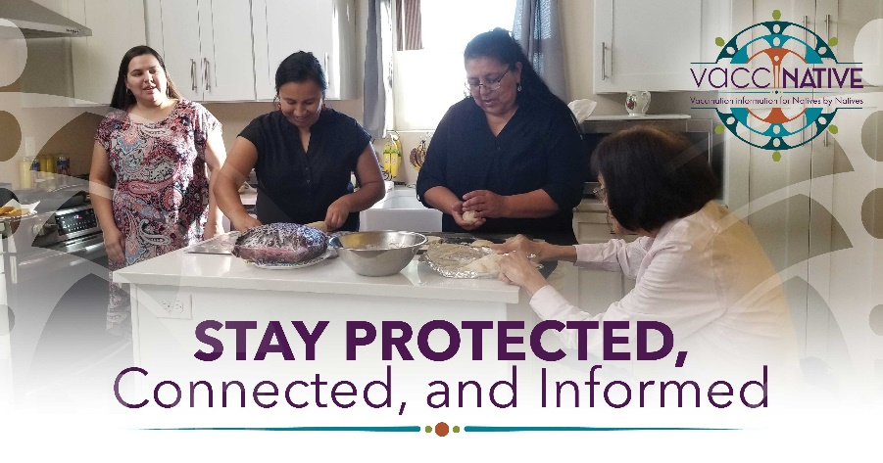
Facebook
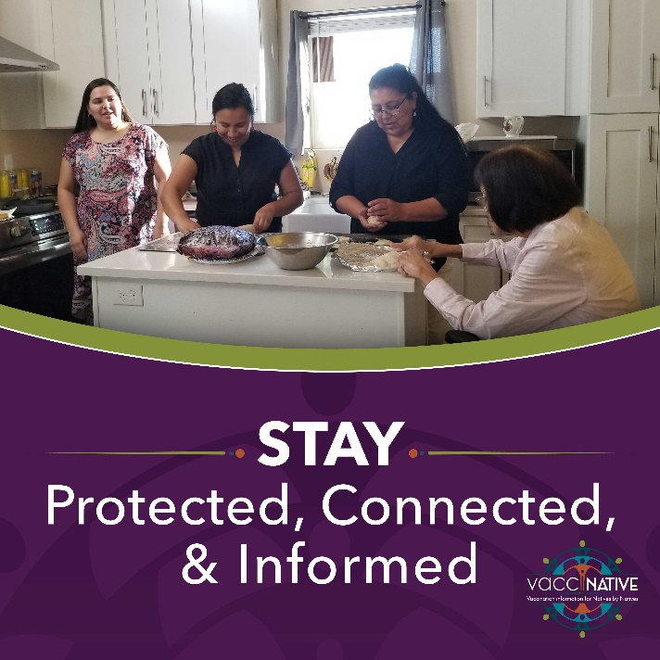
Instagram

